

**Faculty of engineering - Shoubra**

**Benha University**

**Research Article / Research Project / Literature Review**

in fulfillment of the requirements of

|  |  |
| --- | --- |
| **Department** | **Engineering Mathematics and Physics.** |
| **Division** | **-------------** |
| **Academic Year** | **2019-2020 Preparatory** |
| **Course name** | **Computer.** |
| **Course code** | **ECE001** |

**Title: -**

**Programming Languages.**

By:

|  |  |  |  |
| --- | --- | --- | --- |
|  | Name | Edu mail | B.N |
| 1 | ابانوب اشرف ابو سفين | abanoub195000@feng.bu.edu.eg | 1 |

**Approved by:**

|  |  |
| --- | --- |
| Examiners committee | Signature |
| Dr.Ahmed Bayoumi |  |
| Dr.Shady Elmashad |  |
| Dr. Abdelhamid Attaby |  |
|  |  |

Student data

**Name:** Abanoub Ashraf Abo Sefeen ابانوب اشرف ابو سفين

**B.N:** 1

**Topic:** Programming Languages.

**Github link:-** [**https://github.com/abanoub195000/ece001**](https://github.com/abanoub195000/ece001)

**Github page:** [**https://abanoub195000.github.io/ece001/**](https://abanoub195000.github.io/ece001/)

**Application brief:**

* **Function and target:-** A computer programming language is a language used to write computer programs, which involves a computer performing some kind of computation or algorithm and possibly control external devices such as printers, disk drives, robots, and so on. For example, PostScript programs are frequently created by another program to control a computer printer or display. More generally, a programming language may describe computation on some, possibly abstract, machine. It is generally accepted that a complete specification for a programming language includes a description, possibly idealized, of a machine or processor for that language. In most practical contexts, a programming language involves a computer; consequently, programming languages are usually defined and studied this way. Programming languages differ from natural languages in that natural languages are only used for interaction between people, while programming languages also allow humans to communicate instructions to machines.

**Abstract:-** Programming languages usually contain abstractions for defining and manipulating data structures or controlling the flow of execution. The practical necessity that a programming language support adequate abstractions is expressed by the abstraction principle .This principle is sometimes formulated as a recommendation to the programmer to make proper use of such abstractions.

**Screenshots:**

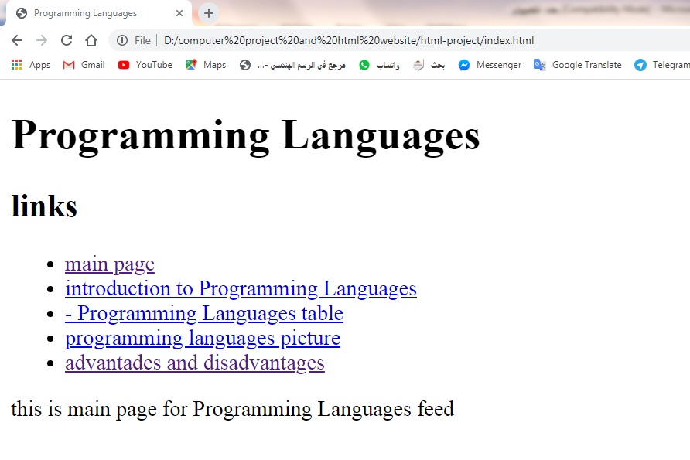

Figure 1:- (mainpage).

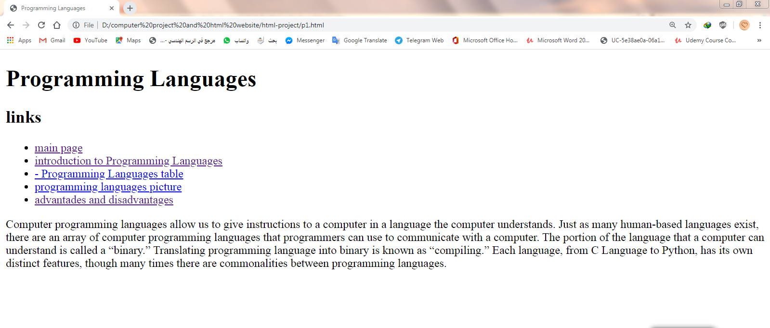

Figure 2:- (introduction to programming languages).

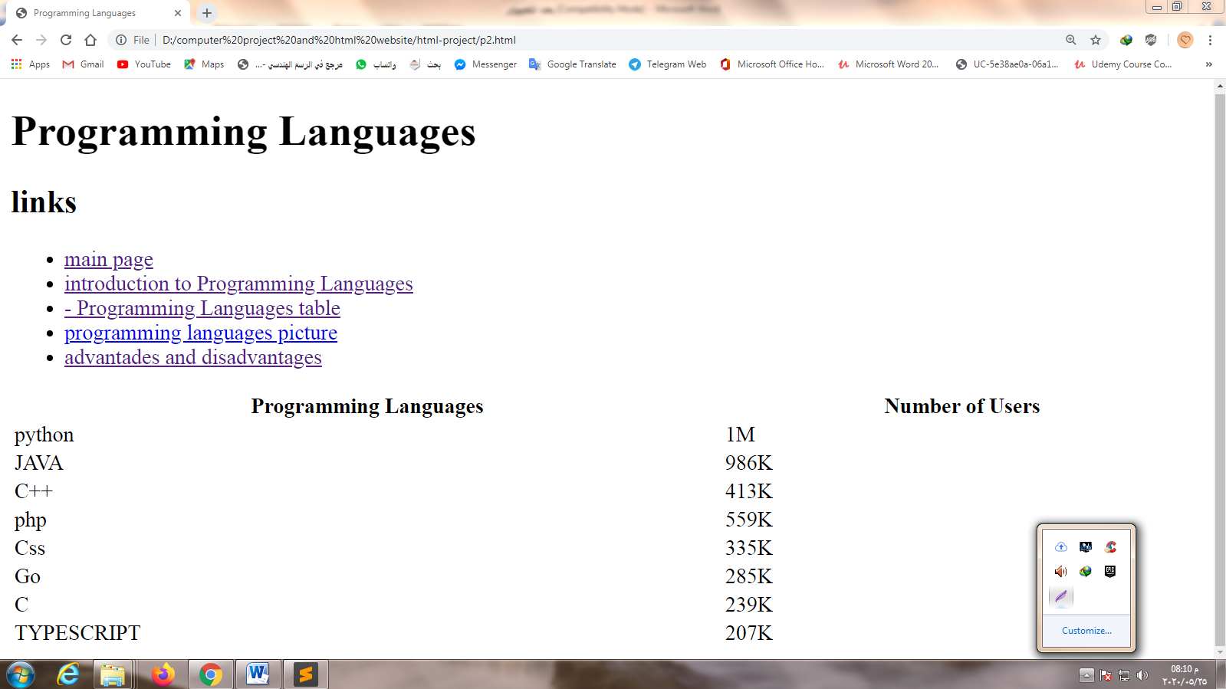

Figure 3:- (programming languages table).

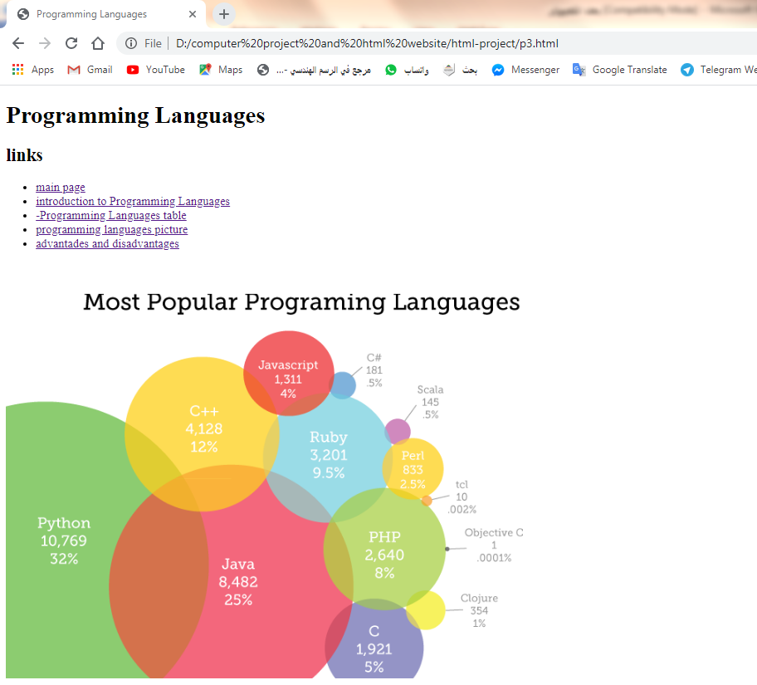

Figure 4:- (programing languages picture).

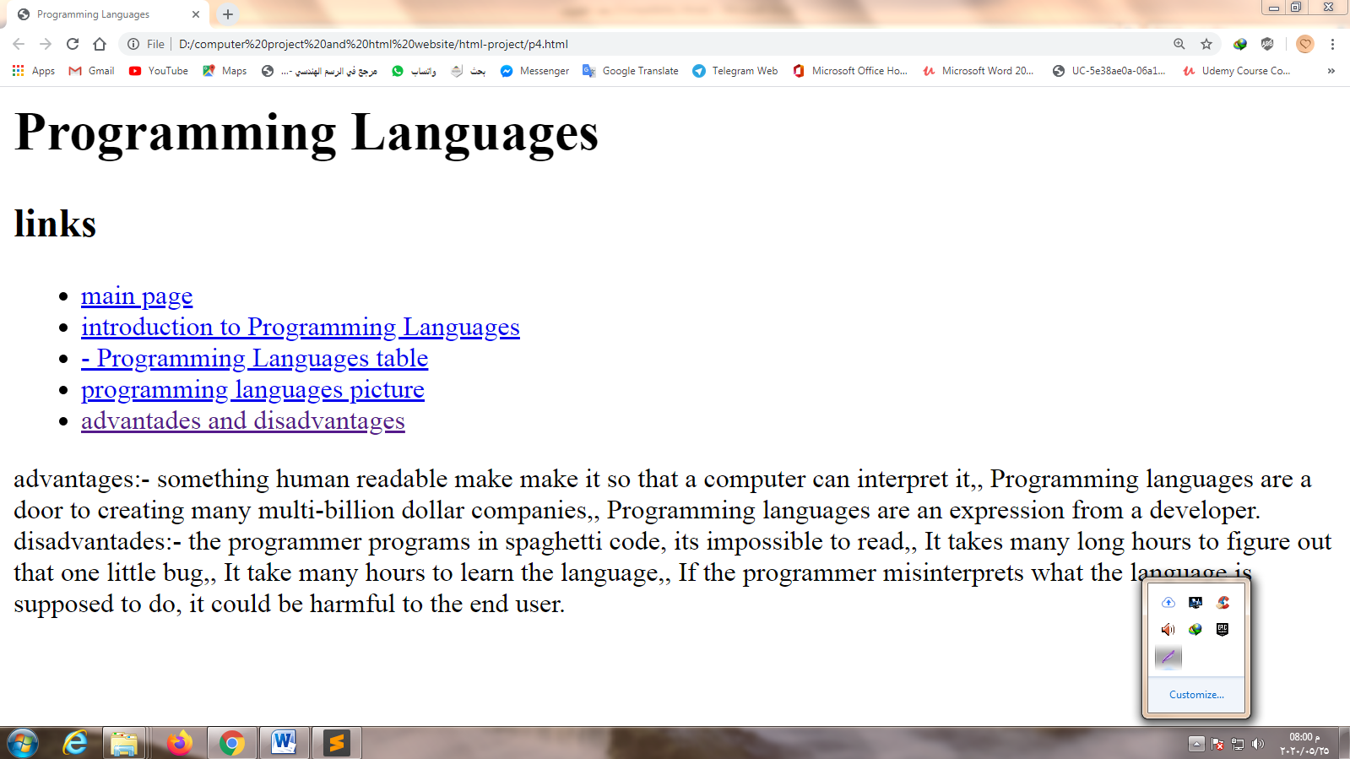

Figure 5 :- (advantages and disadvantages).

**Source code:-**

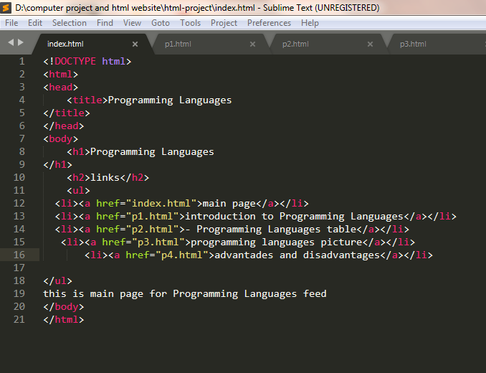

Figure 6 :- (mainpage code).

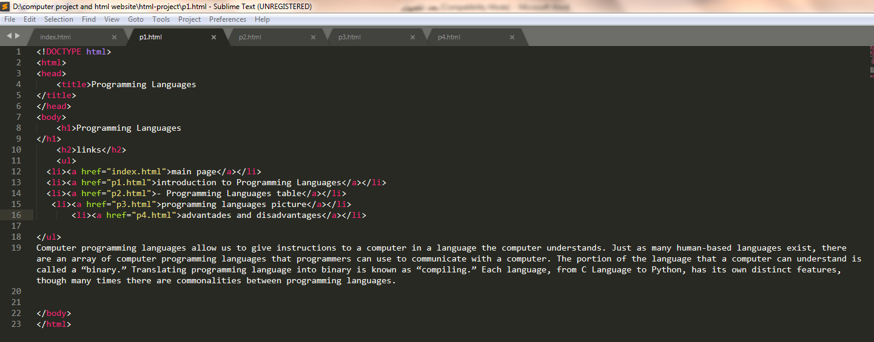

Figure 7:- (programming languages introduction code).

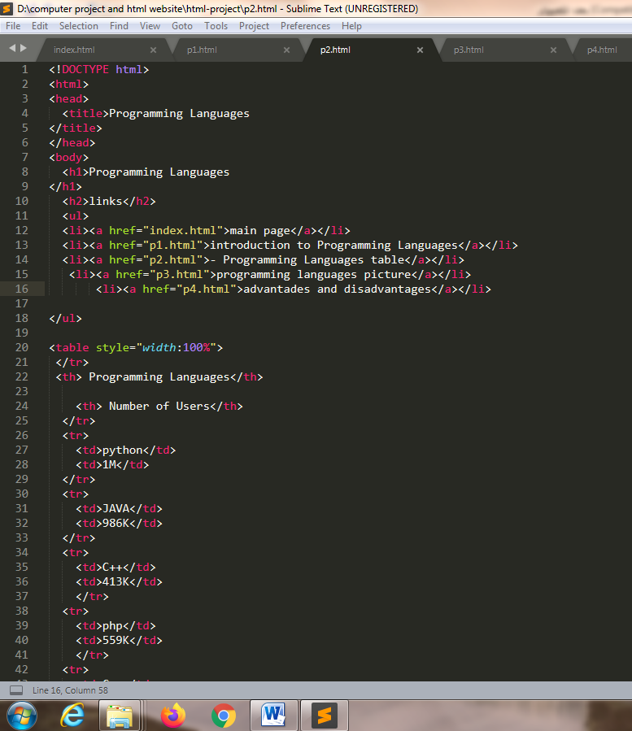

Figure 8:- programming languages table code part 1.

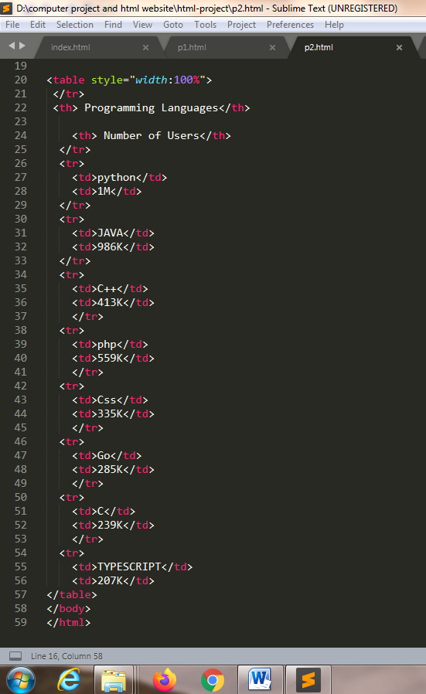

Figure 9:- programming languages table code part 2.

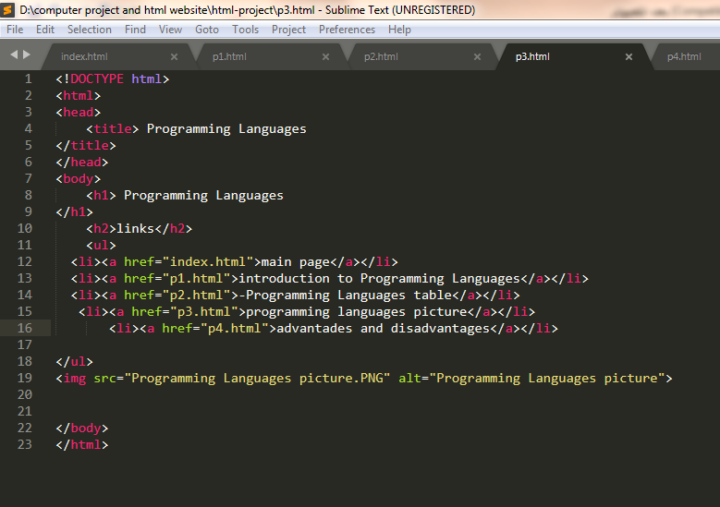

Figure 10:- (programming languages picture code).

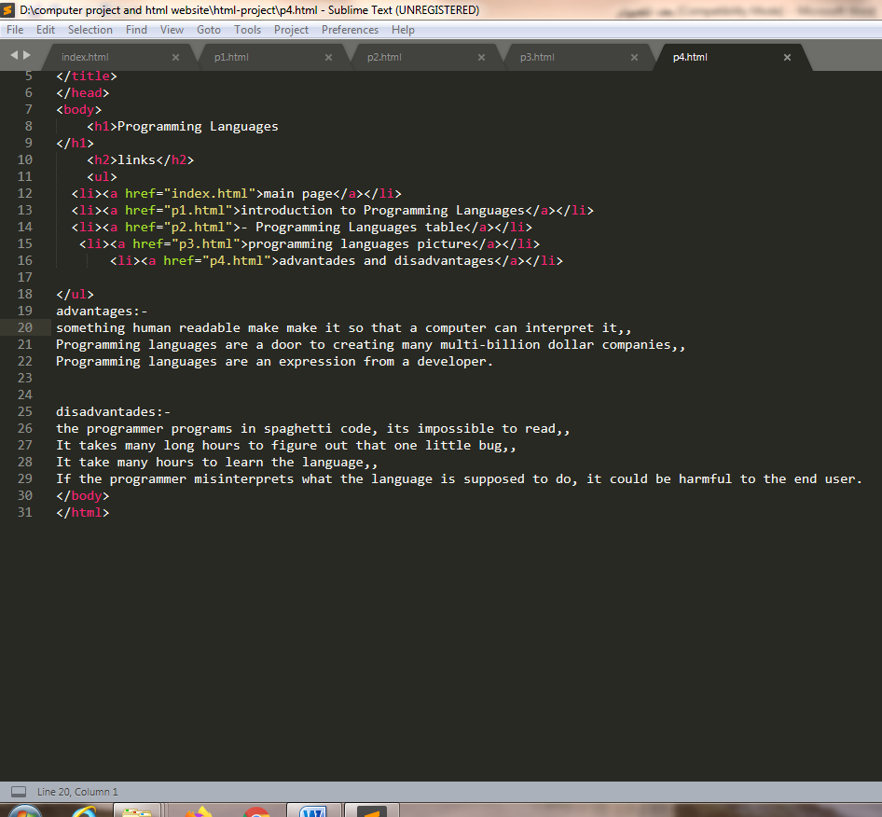

Figure 11:- (advantages and disadvantages code).

**References.**